# Tyler Tirado Project Two CS-255

# CS 255 System Design Document Template

## UML Diagrams

### UML Use Case Diagram

### UML Activity Diagrams

### UML Sequence Diagram

### UML Class Diagram

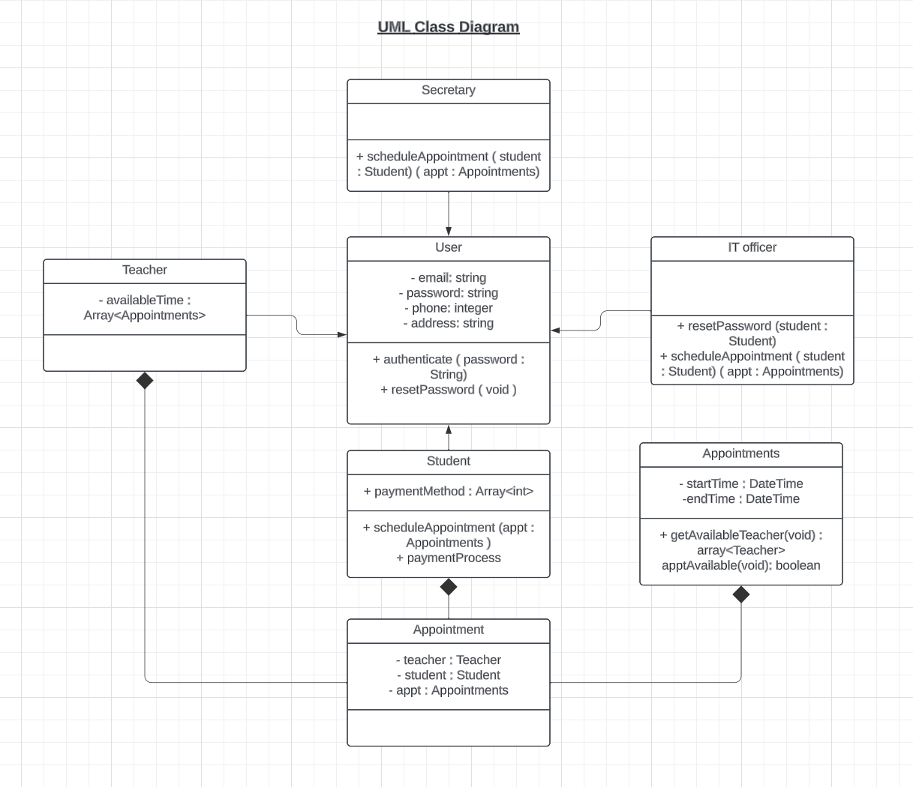

## Technical Requirements

*The technical requirements of the system described above is as follows:*

* *Computer capable of running a standard operating system such as Windows, Linux, MacOS.*
* *Computer capable of running a standard web browser such as Edge, Firefox, Chrome.*
* *A constant and secure internet connection.*
* *A user-interface and a backend system to help store and access data. A database management system such as MySQL or NoSQL would work to store and manage data.*
* *The system should be designed with scalability in mind as the system expands and changes.*
* *A payment processing service that handles payments and payment information.*
* *Role-Based User account permissions that allow different levels of user roles (e.g., IT officer, Secretary, Teachers, Students) to access different parts of the website and alter information.*
* *A responsive user interface that will work with various devices including smartphones, tablets, computers, etc., and will help create a seamless user experience.*